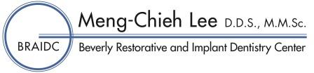

Authorization for release of dental records and dental radiographs

Date____________________________

Dr._____________________________________________________________________
Dentist from who you are requesting x-rays.

I, _____________________________________________________________________,
Please print, patient name or guardian name if under 18,
hereby authorize the release of _____________________________________________’s
^{Patient, please print}
dental records and dental radiographs to:

Beverly Restorative and Implant Dentistry Center
Dr. Meng-Chieh Lee D.D.S.
100 Cummings Center Suite 128-Q
Beverly, Ma 01915
978-232-9003 E-mail: roz@braidc.com

Patient signature ________________________________ Date___________________________
(Guardian signature if under 18)

Please forward the appropriate records and radiographs preferable by e- mail or postal mail if necessary so they will be available for my appointment on________________________ at the BRAIDC office.

Thank you

